EMA Name_______________________________
Slope Date___________________Period_______
Find the slope of the following points using the formula for slope. $m=\frac{rise}{run}=\frac{y_{2}-y_{1}}{x_{2}-x_{1}}$
1. (6, 3) and (7, $-$4) 2. ($-$1, 2) and (3, 4)

3. (1, 2) and ($-$1, 2) 4. (1, $-2)$ and (1, 3)

Write the equation of the following lines. Your final answer should be in slope-intercept form$\left(y=mx+b\right)$.
5. slope = 2, y-intercept = $-$6 6. slope = $-\frac{3}{5}$, y-intercept = $0$

7. slope = 3, passes thru (5, $-$2) 8. slope = $-\frac{5}{3}$, , passes thru ($-$3, $-5$)

9. horizontal line that passes thru ($-$3, 4) 10. Vertical line that passes thru ($-$5, 2)

Write the equation of the following lines. Your final answer should be in slope-intercept form$\left(y=mx+b\right)$.
11. ( $-1$, 3) and (2, $-$3) 12. (2, $-$2) and (3, 2)

13. ( 5, 9) and (3, 9) 14. ($\frac{7}{3}$, $\frac{4}{3}$) and ($-\frac{1}{3}$, $\frac{2}{3}$)

Find the slopes of each of the lines below.
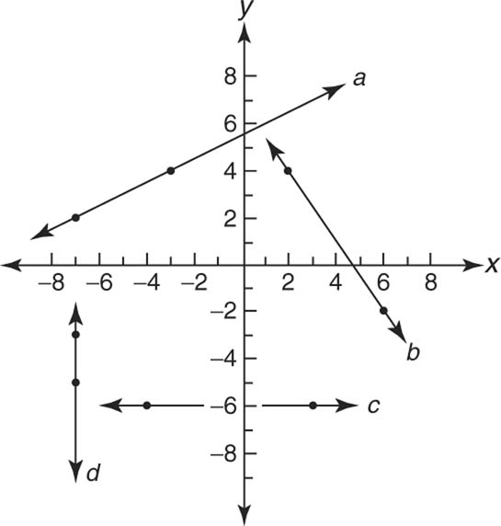
a = ___________

b = ___________

c = ___________

d = ___________

